Using [PokéAPI](https://pokeapi.co/), I will create a data pipeline in python to extract and transform data about Pokémon in a MySQL database. From there, I’ll analysis different aspects of the data in python and SQL

Firstly, by using the requests package and a Pokémon object, I will create a list containing the information of every Pokémon, then convert the list into a pandas DataFrame as a more easily accessible form.

I will do the same for Pokémon types, ending up with a DataFrame of Pokémon types and a corresponding type ID

Can export the Pokémon data now in the form of a csv and parquet file

However, for more functionality, I will export both DataFrames into a MySQL Database. The following Database and tables are created

![Pokémon Database erd](PokemonDB_erd.png) 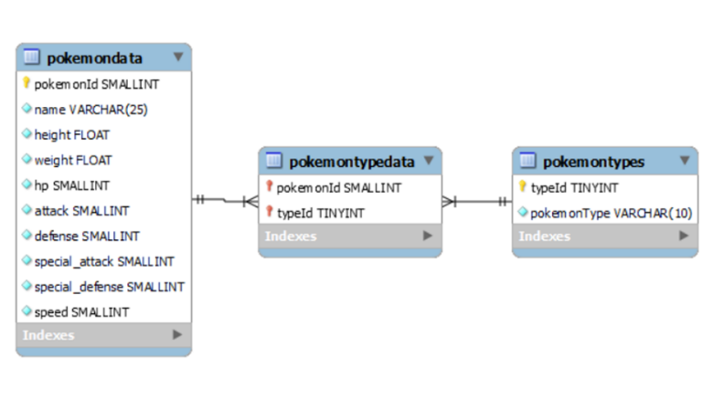

Can now populate the db with the DataFrames, making sure the insert the parent table’s data first then the child’s.

This will only work if all the tables are empty, otherwise the data insertion will fail

Use Pokémon API to create a pipeline to a database or csv

Convert the Json of every Pokémon into an object then transfer data into the DB. Then with the data in format, analysis data and visualise it in a notebook

Main question:

How a Pokémon’s Type is likely to affect its physical traits

Questions to ask:

1. Pokémon type

how are the Pokémon type disturbed:

What are the most popular and least popular types

What is the most popular type pairing

1. Pokémon height/weight

How are height and weight disturbed among Pokémon

What relationship does weight and height in Pokémon follow

--scatter graph

Does weight/height collate to type -> mean height/weight for each type

Scatter, cluster

1. Stats

Trend of stats among Pokémon

For each stat, highest and lowest mean for each type

Do certain types have higher overall stats (total stats)